[ZANG] - [Chuanjie] - ITCAssignment

Student ID: 699382953

[chuanjiezang@gmail.com](mailto:chuanjiezang@gmail.com)

**Assignment 2: ABC Insurance**

**Part 1.**

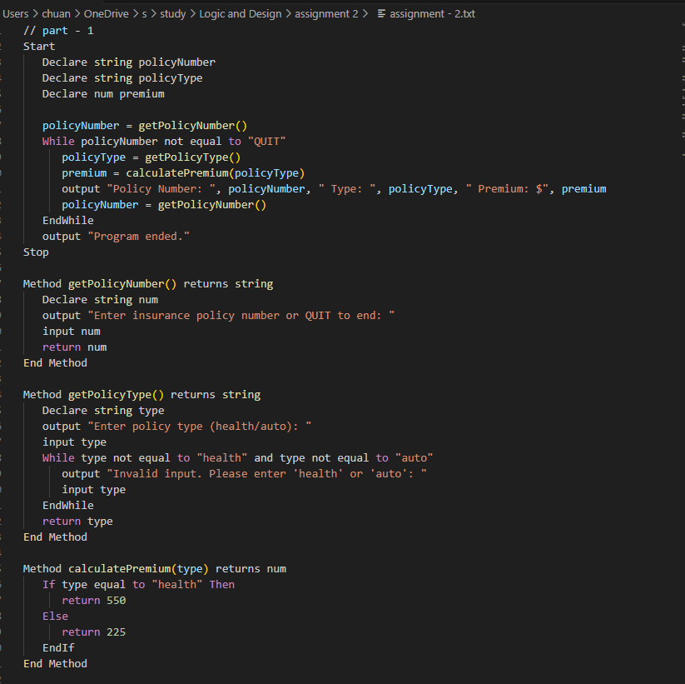

**Part 2.**

In this modified version, the calculatePremium method now calls either the calculateHealthPremium or calculateAutoPremium method depending on the policy type. These two new methods handle the calculation of health and auto insurance premiums, respectively, and determine the premium amount based on whether the user is a smoker and the number of traffic tickets received in the past three years.

